PRACTICAL – 01
OPERATING SYSTEMS AND SYSTEM PROGRAMMING
PRACTICAL – 01
Title: Process Creation and Execution using fork(), exec() and wait()
Name: Shreyas.K
Roll No.: 2520030119
Course: Operating Systems and System Programming
Practical No.: 01

1. AIM
To develop a C program using Linux process-related system calls such as fork(), exec(), and wait() to understand process creation, parent-child relationships, and process execution.
2. OBJECTIVES
- To understand the concept of a process.
- To create a child process using fork().
- To understand the difference between parent and child processes.
- To use the exec() family of system calls for program execution.
- To use wait() for parent-child process synchronization.
- To observe Process IDs (PID) and Parent Process IDs (PPID).
3. THEORY
A process is a program in execution. In Linux, processes are identified using a unique Process ID (PID).
The fork() system call creates a new child process from an existing parent process.
After fork():
• The parent process receives the PID of the child.
• The child process receives 0.
• A negative value indicates that process creation failed.
The exec() family of system calls replaces the current process image with a new program.
The wait() system call allows a parent process to wait until one of its child processes terminates.
The basic process relationship is:
Parent Process
↓
fork()
↓
Child Process
↓
exec()
↓
New Program
↓
exit()
↓
Parent uses wait()
4. PROGRAM
File: process.c
#include <stdio.h>
#include <unistd.h>
#include <sys/wait.h>
#include <stdlib.h>
int main()
{
pid_t pid;
printf("Parent process started.\n");
printf("Parent PID: %d\n", getpid());
pid = fork();
if (pid < 0)
{
perror("fork failed");
return 1;
}
if (pid == 0)
{
printf("\nChild process created.\n");
printf("Child PID: %d\n", getpid());
printf("Child PPID: %d\n", getppid());
execlp("ls", "ls", "-l", NULL);
perror("exec failed");
exit(1);
}
else
{
printf("\nParent is waiting for child...\n");
wait(NULL);
printf("Child process completed.\n");
printf("Parent process terminating.\n");
}
return 0;
}
5. COMPILATION
gcc process.c -o process
6. EXECUTION
./process

7. OUTPUT
Screenshot 1 – Program Execution
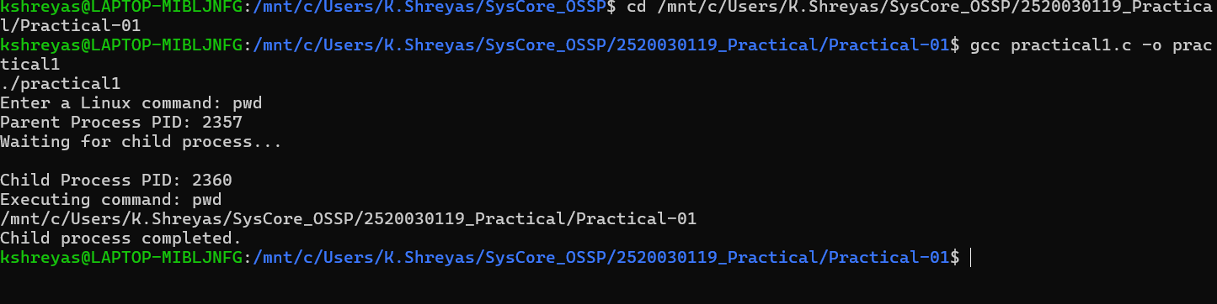
8. OBSERVATION
The program first executes the parent process.
The fork() system call creates a child process. The child displays its PID and PPID and then executes the ls -l command using execlp().
Meanwhile, the parent process waits for the child using wait().
After the child finishes execution, the parent continues and terminates.
9. SYSTEM CALLS USED
fork() – Creates a child process.
exec() / execlp() – Replaces the child process with another program.
wait() – Waits for child process termination.
getpid() – Returns the current process ID.
getppid() – Returns the parent process ID.
10. CONCLUSION
The practical successfully demonstrated Linux process creation and execution using fork(), exec(), and wait(). The parent-child relationship was observed using PID and PPID. The experiment also demonstrated how the parent synchronizes with the child process using wait().

